Bangkok -Pattaya 5day4night
(Private)
Highlights :Wat arun / Nong nooch village / Dolphinarium Show / Mong change Café
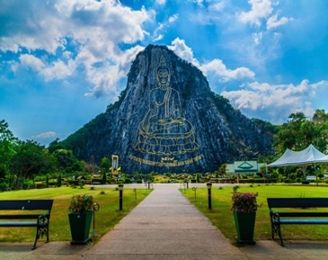
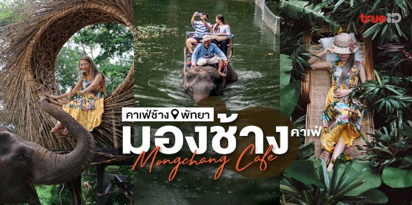
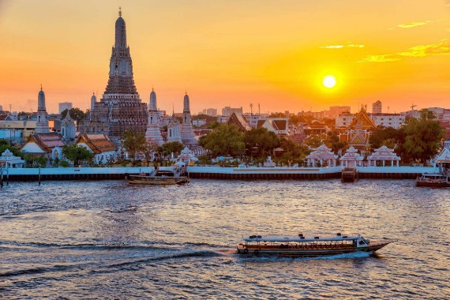
Tour code: BP-05

Day 01 : Flight arrive to Bangkok
Assemble at the airport for your flight to Bangkok. Upon arrival, meet and greet our local representative and transfer to the hotel for check-in. In the evening, visit JODD FAIRS Night Market for shopping and local experiences. Enjoy dinner at your own expense.

DAY 02 BANGKOK – PATTAYA (Breakfast / Lunch / Dinner)
- Nong Nooch Tropical Garden Explore one of Thailand’s most beautiful botanical gardens, featuring stunning landscapes, cultural shows, and themed gardens.
- Pattaya Floating Market Experience the charm of local Thai life as you stroll through canals lined with traditional shops and food stalls.
- Khao Chi Chan (Buddha Mountain) Marvel at the 130-meter-tall Buddha image carved into the mountain face — an iconic landmark visible from afar.
- Pattaya Walking Street Discover the vibrant nightlife hub of Pattaya, filled with entertainment venues, restaurants, and lively street scenes.

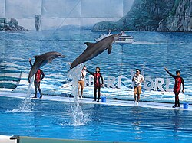
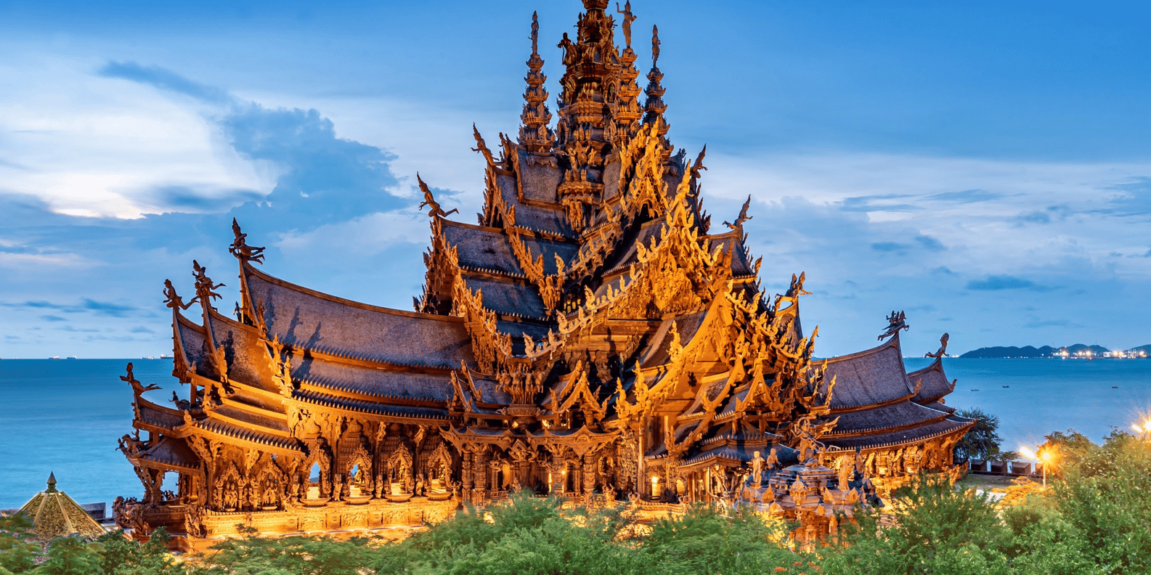

DAY 03 PATTAYA (Breakfast / Lunch / Dinner)
- Mong Chang Café (Complimentary Coffee or Thai Tea) – Enjoy a relaxing break before visiting Terminal 21 Shopping Mall for some free time to shop.
Continue to visit The Sanctuary of Truth, a magnificent wooden temple showcasing traditional Thai craftsmanshi
DAY 04 PATTAYA – BANGKOK (Breakfast / Lunch / NO)
Pattaya Dolphinarium – Experience a marine adventure that will introduce you to the beautiful world of dolphins after transfer to Bangkok visit
Wat Arun – Boat ride along the Chao Phraya River and visit the legendary Wat Arun. Stop by the Temple of the Golden Buddha and admire the golden statue weighing over 5.5 tonnes
Icon Siam Mall – Free time for shopping ASiatique River front ( Dinner by owm)

DAY 05 BANGKOK-Departure (Breakfast) Transfer to airport for your flight. Bringing back wonderful memories and superb souvenirs from your holiday

